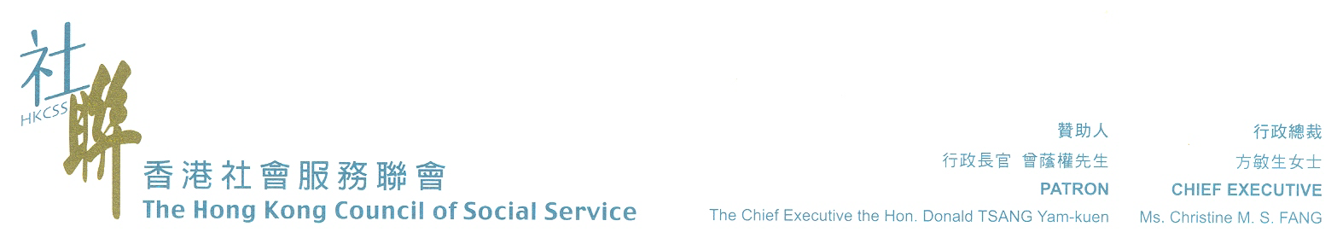
Hong Kong Joint Council for People with Disabilities

M E M O R A N D U M

To : All Agency Members of Hong Kong Joint Council for People with Disabilities and
Hong Kong Council of Social Service
Members of Network on Services for Persons with Mental Illness
Concerned Government Departments/Organizations
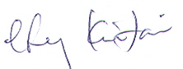
From : Cheung Kin Fai
Chairperson, HKJPD

Subject : 2009 World Congress of the World Federation for Mental Health
[September 2 - 6, 2009 (5 days); athens, greece]

Date : May 11, 2009

I am please to inform you that the Council has solicited funding to subsidies 3 delegates on 50% basis to attend the captioned event.

Basic information of the Event and the estimated expenses per delegate and subsidy application criteria can be found at HKCSS website:

<http://www.hkcss.org.hk/irn/events0910/SubsidizedEvents0910.html>

To apply for subsidy, please complete the Subsidy Application Form which can be downloaded at the above website. If you have difficulties with internet access, please contact us to make alternative arrangement. Completed forms should reach the Council, Room 1212, Duke of Windsor Social Service Building, 15 Hennessy Road, Wanchai, Hong Kong on or before June 11, 2009 (Thursday). Please mark “Confidential” on the envelope and all information will be treated in strict confidence. Please note that late applications will not be considered.

Should you have any queries on the subsidy application procedures, please contact Ms. Agatha Tang, Rehabilitation Officer, at 2864 2939 or by email to <agatha.tang@hkcss.org.hk>.

Thank you for your attention and I look forward to your active participation.

c.c. Mr. Kuo Chun Chuen, Rehabilitation Chief Officer, HKCSS


